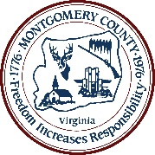
Please note as much information as possible to assist in the investigation.
Contact Montgomery County Environmental services at (540) 394-2090
or email our Stormwater Specialist at burkejw@montgomerycountyva.gov

Please describe the incident.
If known, please include a description of the type and estimated amount of material(s) involved.
If known, indicate if materials entered a storm drain or surface waters (streams, ponds, or wetlands).
Please any information on the person, company, or entity responsible, if known.

Please describe the location of the incident.
From nearest address, intersection, main road, or waterway.

Is the incident still occurring?
Note the time and/or time span that the incident was observed.

Were other agencies alerted to the incident?
Please note notifications to police, emergency services, VDOT, EPA, DEQ, etc., so we can coordinate our responses.

Contact Information
If you wish to remain anonymous, leave this section blank.
Otherwise, please provide your name, phone number, email contact and address.

